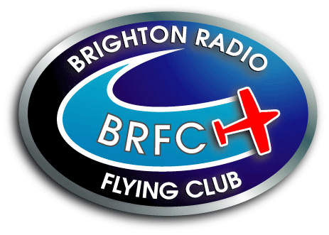  Affiliated to the British Model Flying  Association Club No.561 | CONSTITUTION  Updated 7th November 2018

CONTENTS

Page No.

1. Introduction …………………………………………… 1

2. Membership …………………………………………… 1

3. Guest and Joint Meetings ……………………………… 3

4. Complaints …………………………………………….. 3

5. Disciplinary Actions …………………………………… 4

6. Instructors/Examiners/Permit to Fly …………………… 4

7. Committee ……………………………………………… 5

8. Voting and Conduct of Meetings ………………………. 6

9. Annual General Meetings ……………………………… 6

10. Extra Ordinary Meetings ………………………………. 7

11. Dissolution of the Club ………………………………… 7

12. Charity Guidelines ……………………………………… 7

13. Guide on Caring for Junior Members ………………….. 8

14. Vulnerable Adults ……………………………………… 9

15. Field Safety Rules ……………………………………… 9

15.1 Club Discipline ………………………………….. 9

15.2 Safety Procedure ………………………………… 9

15.3 Flying Competency ……………………………… 10

15.4 Flying Hours …………………………………….. 10

15.5 Flying Etiquette …………………………………. 10

15.6 No Fly Zones ……………………………………. 11

15.7 Strip ……………………………………………... 12

15.8 Frequency Control and Transmitters …………….. 13

15.9 Pit and Engine Starting ………………………….. 14

15.10 Gas Turbines …………………………………….. 15

15.11 Field Security…………………………………….. 15

15.12 Vehicles …………………………………………. 16

15.13 General ………………………………………….. 16

Appendix A - Permit to Fly Test Sheet …………………….. 17

Appendix B - Incident Report form ......……………………. 18

Appendix C – GDPR …………….......……………………. 19
BRIGHTON RADIO FLYING CLUB

Affiliated to the British Model Flying Association. Club No.561

CONSTITUTION V.6

This constitution document updated 7th November 2018 supersedes all previous rules.

1 INTRODUCTION

1.1 The Club will be called Brighton Radio Flying Club (BRFC) and will be affiliated to the “British Model Flying Association” as from the first day of January 1993.

  - The Club’s principle aim shall be the promotion of safe and responsible model aircraft flying.

  - The Club will not be used for the furtherance of commercial gain or any other commercial activities.

  - Any alteration to the Club’s Constitution should only be made at an AGM, however, any proposed alterations which need to be made prior to the AGM, ie. amendments to Club Rules or BMFA guidelines, must be submitted in writing to the Secretary at least 14 days prior to the next available Committee meeting.

  - All members, without exception, must obey all club rules. Failure to do so may result in disciplinary action by the Club which may lead to membership of BRFC being revoked.

  - All field safety rules and regulations will be reviewed annually, and will be considered binding for 12 months, excepting where urgent action is required. This action must then be ratified by the Committee at the next club meeting or at a general meeting. The BRFC field safety rules are considered as a supplementary code to those laid out by the British Model Flying Association’s Members’ Handbook, compliance with which is mandatory within BRFC.

  - In line with GDPR requirements, all members will receive a copy of the club Privacy Notice on joining, which will be updated from time to time. A copy can be viewed on the club website or provided on request. Signature of the BRFC membership form will be consent to the club keeping and using personal data as described in the Privacy Notice, for all members.

2. MEMBERSHIP

  - There are eight categories of members within the Club. All members will pay the annual BMFA fee.
    - Full Members (18 years and over) will pay the full Club annual subscription.
    - Family Partner Members will pay 50% of the full Club annual subscription.
    - Student Members (over 18 years but still in full time education) will pay 50% of the Club annual subscription
    - Junior Members (11 - 18 years) will pay 50% of the Club annual subscription.
    - Junior Members (10 years and under) will be entitled to free membership.
    - Family Junior Members will pay one third of full Club annual subscription.
    - Non-Flyer Members will pay £30 annual subscription.
    - Honorary Member – annual subscription fee is voluntary, all other fees payable.

  - A “member” means any class of membership.

  - All Junior member application forms must be countersigned by a parent or guardian if the applicant is under 18 years of age. (See item 13 “Guide on Caring for Junior Members”)

  - All flyer members must have current membership of the British Model Flying Association and must be able to provide evidence of such on request.

  - Only existing members can apply to become non-flying members of the Club.

  - Non-flyer members are not required to have current BMFA membership unless they are actively involved in an organisational capacity in the Club. Eg. Non-flyer committee member.

  - Non-flying members must return their Permit to Fly card to the Committee, however, they may retain their gate keys to enable access to the field for social purposes only.

  - Subscriptions shall fall due on the first day of December, and must be paid in full by the February club meeting of the following year. Failure to do so will forfeit membership and the ex-member will be required to re-apply to the Committee for re-election and will be levied the joining fee.

  - Members who have not renewed their membership by 31st December will be suspended from all flying activity until they re-join the club

  - All new applicants for membership are required to attend, by arrangement, a club Committee meeting before being formally accepted. The applicant will be given the opportunity to prove his/her competence to fly or to arrange tuition.

  - The Committee has the right to refuse membership to new applicants.

  - Members whose membership has been terminated by the Committee will no longer be permitted to visit the field.

  - Applicants will be accepted from outside Brighton and Hove area up to a limit of ninety members, the last ten membership places are held in reserve for Brighton and Hove residents. The Committee will give priority to applicants who do not hold membership of another club. Any member who leaves the area shall be entitled to retain and renew his/her membership.

  - New members will be required to serve an initial probationary period of 6 months and may have their membership terminated at the discretion of the Committee for unsatisfactory conduct. The probationary period may be extended by a further six months at the committee’s discretion.

  - New members are not eligible to serve on the Committee during the probationary period.

  - All new members will be levied a joining fee.

  - Those joining on or after July 1st shall be entitled to a 50% reduction on subscriptions, however, the full joining fee must be paid.

  - Brighton Radio Flying Club has existing members who have been granted Life Honorary membership. It is not the intention of the club to offer new Honorary memberships, however, in the event that a member makes a very significant and exceptional contribution to the club the Committee reserve the right to propose new Honorary memberships subject to the approval of the club membership by a vote at the AGM. Honorary membership makes the obligatory annual club membership fee voluntary but does not affect the requirement for members to hold BFMA membership or change the requirement to pay other levies agreed by the club.

3. GUEST AND JOINT MEETINGS

3.1 When there is a joint meeting between BRFC and another club, the participating club must be able to provide evidence of current BMFA membership and insurance cover in advance of the event.

  - Members may invite guest fliers to the site on arrangement with the Committee but they must be BMFA insured and the club member must assume total responsibility for the actions and safety of the guest. Permission per visit must be obtained at least one week in advance of the visit and a register kept. This is a requirement of the Council under item 13.10.14 of the lease. Guests must fly under the BRFC club rules and should have BMFA A certificate or fly under the supervision of an instructor if their abil`ity requires it. Guests must be accompanied and supervised at the flight line by a competent certificate (Permit to Fly) holder of at least 6 months. The Committee reserves the right to ask any non member to leave the field.

  - The Committee may from time to time invite another club to the field to fly in an event. The Committee must be satisfied that the other club is affiliated to the BMFA and carry BMFA insurance. Any such event shall be run strictly in accordance with BRFC rules. The Committee may invite on June, July or August club nights a guest or guest fliers for demonstrations or entertainment purposes.

  - A potential member or non BMFA guest will be permitted to have three flight sections at the club field when under the supervision of a club tutor or committee member. These flights are permitted under the BMFA insurance and must be carried out in accordance with the BMFA Handbook.

4. COMPLAINTS

  - Any complaint concerning any member must be made in writing and signed by the complainant(s).

  - The complaint must contain the date and time of the incident, the person’s name, what exactly occurred (a good description of the events) and the names of any witnesses.

  - The written complaint must then be forwarded to the Secretary who will:

a Within 7 days of receiving the complaint, send a written acknowledgement to the complainant(s).

b. Within 7 days of receiving the complaint, send a letter to the person named by the complainant, requesting their version of the incident. This will carry a seven day written response clause.

c. If no response is received, a further letter will be issued by the Club Secretary stating that the Committee will consider all the available evidence at their next meeting.

d. Add the complaint to the agenda of the next available Committee meeting.

e. Inform all concerned of the date and time of the meeting and request them to attend with witnesses if desired.

  - If the person named by the complainant does not attend the meeting without just cause, the Committee will consider all the evidence in their absence and the person will be informed in writing of the Committee’s decision.

  - Upheld complaints will be lodged with the Club Secretary and may be the subject of further consideration of any subsequent complaints against that Club member.

  - Committee members who are a party in a complaint, cannot sit on the Committee that adjudicates the complaint.

5. DISCIPLINARY ACTIONS

5.1 Any member who is found to have infringed any of the Clubs rules may be suspended from flying for one calendar month and may be subject to further disciplinary action.

  - The Committee may impose a flying suspension not exceeding 90 days upon any member in the event of misconduct. Any suspension must be accompanied by a written warning. A record of any suspension must be made in the Committee meeting minutes.

  - Any member flying after the Committee member(s) have, for any reason closed the field, will be suspended from flying for one calendar month and may be subject to further disciplinary action.

  - The Committee may consider dismissal from the Club of any member whose conduct on the field or elsewhere is considered to be prejudicial to the Club. Dismissal will be in accordance with the following procedure in order to comply with the laws of natural justice:

    - The member is to be given a verbal warning by an authorised Committee Member in which the member is made aware of his misdemeanour and what he/she is reasonably required to do to make amends.

    - If the member does not respond, he/she is to be given a written warning by an authorised Committee Member to advise him/her of his/her misdemeanour and what he/she is reasonably required to do to make amends.

    - If he/she still fails to respond, the Committee should invite him/her in writing to meet with them at a previously agreed date and time to discuss the situation, advising they are considering withdrawal of his/her membership.

    - If he/she still fails to respond to reasoning or fails to attend the meeting without reasonable cause, the Committee can advise him/her in writing that his/her membership is withdrawn, stating the reasons why this decision was reached.

  - In the event of gross misconduct, immediate suspension without warning may be imposed but the member will still be accorded his/her rights to present his/her case to the Committee and be given a right of a hearing in accordance with sub-paragraphs c and d above.

  - In the event of dismissal no membership or joining fees will be refunded.

6. INSTRUCTORS/EXAMINERS/CLUB PERMIT TO FLY TEST

  - The Committee, Officers, Instructors and Examiners, will be responsible for the running of the flying field at all times.

  - Appointment to the position of Instructor or Examiner will be made by the Committee at a Committee meeting.

  - All flying members must attain the minimum standards of flying required under the BRFC training scheme and pass the BRFC “Permit to Fly” test before being allowed to fly un-supervised. See Permit to Fly Test sheet Appendix A.

  - Gyro-assisted aircraft may not be used when undertaking the BRFC permit to fly test.

  - Buddy box systems may not be used when undertaking the BRFC Permit to Fly test.

  - Any member whose flying capabilities, in the Committee’s opinion, drop below the minimum unsupervised standard will be required to retake the Permit-to-Fly test and, if unable to meet the standard, will need to re-join the training scheme until able to retake and pass the Permit-to-Fly test.

  - Club BMFA Examiners and BMFA registered Instructors are authorised to conduct the Club “Permit to Fly” test in addition to Club Committee members. An examining group will consist of:
    - EITHER One committee member and two examiner/instructors
    - OR Two committee members and one examiner/instructor

7. COMMITTEE

  - The Committee of the Club shall comprise of not more than 10 members.

7.2 The Committee of the Brighton Radio Flying Club shall consist of a Chairman, a Vice-Chairman, an Honorary Secretary, an Honorary Treasurer and at least two Committee Members.

  - The City Council of Brighton and Hove require at least three named trustees to sign the lease for the field. They shall be the current Chairman, Vice-Chairman and the Honorary Treasurer.

  - Committee members shall be elected from written nominations, at the Annual General Meeting, to serve for a period of one year. The Committee will be elected by majority vote by a show of hands from eligible members present.

  - The quorum for the Committee shall consist of four members, at least two of whom must be either Chairman, Vice-Chairman, Honorary Treasurer or Honorary Secretary.

  - Should a Committee position become vacant, the Committee may co-opt a replacement who will then serve until the following Annual General Meeting. This will be by a majority vote from the Committee Members.

  - Members elected to office will have full voting rights at all meetings. In the event of a tie the Chairman will have the casting vote.

  - The Trustees reserve the right to carry out negotiations and make decisions in the interest of the club or on behalf of the membership where necessary without consulting the other Committee members.

  - The Treasurer and Chairman are required to submit a sample of his/her signature for banking reference purposes.

  - Money may only be withdrawn from the fund by cheque if signed by either the Treasurer or Chairman.

  - The Secretary must be informed of any negotiations proposed by club members that affect the Club as a whole and copies of any written correspondence must be submitted to him/her for record purposes.

  - The Secretary will receive an annual honorarium to cover out of pocket expenses not covered under the normal conditions of withdrawal from club funds as stated in item 7.10, the amount of which will be decided at the Annual General Meeting. He/she may also present a monthly claim towards additional administration costs for consideration by the Committee.

  - No member of the Committee or Officer of the Club may be a Committee Member or Officer of another model flying club.

  - Any Committee Member or Officer wishing to resign should inform the other Committee members in writing.

  - Any member of the Committee who is absent from three consecutive Committee meetings without reasonable cause will automatically forfeit his seat on the Committee.

  - The Committee may pay accounts and incur any normal liabilities on behalf of the Club. If a Committee Member engages or becomes involved in court proceedings, whether criminal or civil in his representative capacity on behalf of the club, as opposed to his capacity as a private individual, the club will indemnify the Committee Member in respect of any fines or damages or costs awarded against the Committee Member.

  - In the event of a Committee Member being awarded damages or costs in the course of proceedings taken by him in his representative capacity, such damages or costs will belong to the Club and not the Committee Member personally and upon receipt that Committee Member will pay them to the Club Treasurer.

8. VOTING AND CONDUCT OF MEETINGS

  - All meetings will follow an agenda and will be minuted. Agenda items will only be accepted at general meetings if the Secretary is given at least 14 days’ notice in writing of the item to be discussed.

  - Voting will normally be by a show of hands; however a secret ballot must be taken should any member request that this be done. Proxy and postal votes will not be allowed.

  - All categories of membership will have full voting rights at club meetings.

  - All proposals must be seconded and voted upon. A majority vote is required to carry any proposal.

  - In the event of a tie, the Chairman will have the casting vote.

  - Amendments to proposals must be voted upon first.

  - Non-Committee members may attend Committee meetings as observers by applying to the Secretary at least 14 days before the meeting.

  - Non Club members may attend Club meetings as invited guests by applying to the Secretary in advance.

  - The Chairman has the power to ask a person to leave any meeting in the event of that person disrupting the meeting.

9. ANNUAL GENERAL MEETINGS

  - The “Annual General Meeting” will be held during November of each year.

  - The AGM must have a quorum of at least 25% of the membership to proceed.

  - At least 28 days’ notice of the meeting will be given in writing to all Club members.

  - Annual subscriptions and the joining fee will be decided at the Annual General Meeting.

  - An Auditor approved by the Committee will verify that the balance sheet is correct and fairly represents the expenditure and receipts of the Club, its assets and liabilities.

10. EXTRAORDINARY MEETINGS

  - The Secretary will convene an Extraordinary Committee Meeting within 14 days on request from any member of the Committee, stating the business to be discussed.

  - An “Extraordinary General Meeting” may be called by the Committee, or not less than 25% of the members of the Club. At least 28 days notice in writing shall be given to the Honorary Secretary, who in turn shall give members at least 14 days notice in writing of the meeting and the agenda. No other business will be transacted at the “EGM”.

  - When a request for a meeting is made and it is not called within 28 days, the requisitioners may themselves convene an Extraordinary General Meeting of the Club by giving 28 days notice in writing to all members, duly setting out the purpose for which the meeting was called. Any resolutions passed at such a meeting shall have the same force and effect as if they were passed at a meeting convened by the Committee.

11. DISSOLUTION OF THE CLUB

11.1 Should it be considered necessary or desirable to dissolve the Club, the Committee will call an Extraordinary General Meeting. Should a quorum fail to appear, the meeting will be adjourned and a further EGM must be called. The second meeting will proceed even if a quorum is not present and the motion will then be carried by a simple majority vote.

  - On dissolution and after the sale of assets, settlement of all outstanding debts and the refund of subscriptions for the remaining part of the year to the paid up members, the funds remaining will be distributed in equal shares to charities chosen by the committee.

  - If the final accounts are less than required to refund the subscriptions to the members, the total money remaining will be donated to the Club’s charities. All members will receive a final statement of accounts.

  - Sufficient funds will be retained in the Club Reserve Account to cover the Trustees’ financial liability, in respect of monies due in the event of early termination of the lease.

12. CHARITY GUIDELINES

  - The aim of these notes is to provide guidance to the Committee of the Club when considering making donations to charity.

  - The Club should, wherever possible, support local charity events when asked. i.e. school summer fairs, firework displays, etc. whenever it is practicable to provide a relevant display of what we do. Whether or not money changes hands largely depends on the circumstances around which the event is based. These conditions should be finalised well before the day of such an event.

  - Only money raised at these events should be made available to donate to worthy causes. No money will be diverted from members’ subscriptions.

  - In the event of the club being approached to donate money to a local worthy cause, the Committee will make a decision on the amount to be donated.

  - In the event that the Club is approached for sponsorship of a member or their close associate who is involved in a charity event, the Committee will make a decision on the amount to be donated.

  - The Club reserves the right to periodically donate funds to charities.

13. GUIDE ON CARING FOR JUNIOR MEMBERS

  - A Junior Member is defined as being under 18 years of age.

  - A responsible adult is defined as a senior member or parent/guardian who:
    - has the experience commensurate with the type and degree of supervision required
    - has been introduced to the Committee by the counter signing parent or guardian (identified in rule 2.3 junior membership) prior to starting any supervision.
    - is conversant with the Club’s Constitution and rules.

  - Junior members must be supervised at all times by a responsible adult. The level of supervision is to be commensurate with the junior member’s age, maturity, capabilities and levels of experience.

  - Junior members under the age of 14 years shall not start an engine or carry a model with the engine running unless they are supervised by a responsible adult.

  - No junior member shall fly a model aircraft unless supervised by a senior member who holds a BRFC Permit to Fly or the junior member holds the minimum of a BRFC Permit to Fly and has been given written permission from the Committee to fly without a senior permit holder member present. A copy of the written permission must be carried at all times. The requirement for a responsible adult (rule 13.3) will still apply to the junior member.

  - No senior member is expected to assume responsibility for a junior member unless he/she has previously agreed with the parent/guardian and has notified the Committee in writing. The senior member will be required to complete a CRB check and will assume complete and total responsibility for the junior member whilst he/she is in their care.

  - Notwithstanding the requirements of Paragraph 13.6, should a member discover a junior member is unsupervised, he/she must assume responsibility for the junior member’s safety in the first instance. The situation should then be rectified as soon as possible by seeking out the junior member’s parent/guardian/nominated supervisor. Any instance of such an occurrence is to be reported to the Committee as soon as possible.

  - Whilst supervising junior members, senior members should be aware of the requirements of The Children Act (1989) and avoid placing themselves in a position that could be open to misinterpretation or question. A leaflet giving advice is available from the BMFA Leicester Office or from the Club Secretary.

  - Parents/guardians and senior members acting as responsible adult for any Junior member must have confirmed in writing that they accept and agree with the BRFC Guide on Caring for Junior Members.

14. VULNERABLE ADULTS

14.1 A vulnerable adult is defined as a person of eighteen years of age or over who, through mental or physical attributes, requires a higher level of supervision than would be normally commensurate with an adult member.

14.2 It is the responsibility of the vulnerable adult member to ensure that they have adequate supervision, whilst using the facilities of the club.

14.3 A vulnerable adult can also be a temporary designation covering persons who may, for instance, be recovering from an illness or medical treatment.

14.4 Members should inform the Committee if they consider they fall within the category of “vulnerable adult” as described above. This is to ensure the safety of all members.

15. FIELD / SAFETY RULES
The following rules and conditions are formulated for the flying of model aircraft at the Saddlescombe Road flying site. It is essential to flying site safety that the following rules are strictly adhered to.

  - CLUB DISCIPLINE

15.1.1 All fliers must observe field discipline and comply with the Air Navigation Order, all relevant BMFA safety codes as contained within the BMFA Members’ Handbook and Civil Aviation publication (CAP) 658.

    - All members are strictly forbidden from flying on any other land that is managed or owned by the City of Brighton and Hove.

    - Due to frequency clashes, and some reported accidents at the Sussex Model Club flying site at Coombes, no radio controlled model flying, by any BRFC member, is to be undertaken at Steyning Bowl.

    - Only members of the Brighton Radio Flying Club are permitted to fly at the site and are subject to these rules and the Club Constitution. Exceptions at item 3 “Guest and Joint Meetings” apply.

  - SAFETY PROCEDURE

15.2.1 On matters of field safety needing an immediate decision, the responsibility lies with a Committee member then an instructor in that order.

    - Committee members, when present at the field, will be responsible for the safety of the site. Any instructions must be accepted without dissent. However, should a member believe the instructions to be wrong, then he/she should bring this to the attention of the Committee.

    - Should a serious accident or incident occur causing injury or damage to people, property or animals, the member(s) involved in the incident must IMMEDIATELY inform a Committee member and give details.

    - All members involved in the incident/accident, including witnesses, must submit an Incident Report form to the Committee (Appendix B). The Committee will maintain an Accident/Incident Register and follow up any necessary action.

    - A supply of Incident Report forms will be kept in the shelter at the field and are also available to download from the Club website.

    - Safety Notices will be issued to all members as required.

  - FLYING COMPETENCY

    - No member shall fly from the site unless:
    - He/she holds a Club competence certificate, known as a “Permit to Fly” card or
    - He/she is accompanied by a competent certificate (Permit to Fly) holder.

    - The permit holder in 15.3.1b must be 18 years of age or over and have held a permit to fly for a minimum of six months. Special dispensation may be given by the Chairman to members under 18 years of age who have held their permit to fly for a minimum of six months and have achieved their BMFA A certificate, to allow them to ‘buddy’ learner members.

15.3.3 Members may only fly rotary wing at the site if they hold a ‘Fixed Wing Permit to Fly’ card. The Club is unable to provide instruction/tuition for rotary wing pilots.

15.3.4 All such certificates (cards) together with membership cards shall be displayed on the member’s flight box. (See rule 15.10 - special requirements for operation of Model Gas Turbines).

  - FLYING HOURS

15.4.1 Flying at the site is only permitted during daylight hours.

15.4.2 Priority will be given to helicopter flyers up to 10.00am seven days a week. At other times helicopter pilots are permitted to fly provided all flyers present at the time agree.

  - FLYING ETIQUETTE

15.5.1 Due consideration must be given at all times to trainee or novice pilots in the circuit. In the event that the pleasure or concentration of a pilot is affected by the flying style of another, precedence will be given to the pilot who was airborne first.

    - Intimidating flying of any sort is not permitted.

    - No more than 6 aircraft shall be airborne at any one time unless a higher limit, not to exceed 10, is agreed by all pilots prior to flying starting.

    - Members should check with other pilots their intentions, if they wish to fly anything other than a circuit, particularly during busy periods when there are several aircraft in flight at the same time.

15.6 NO FLY ZONES

15.6.1 There is no flying beyond the eastern boundary fence or a line extended through that fence of the Club’s Flying site. (see diagram)
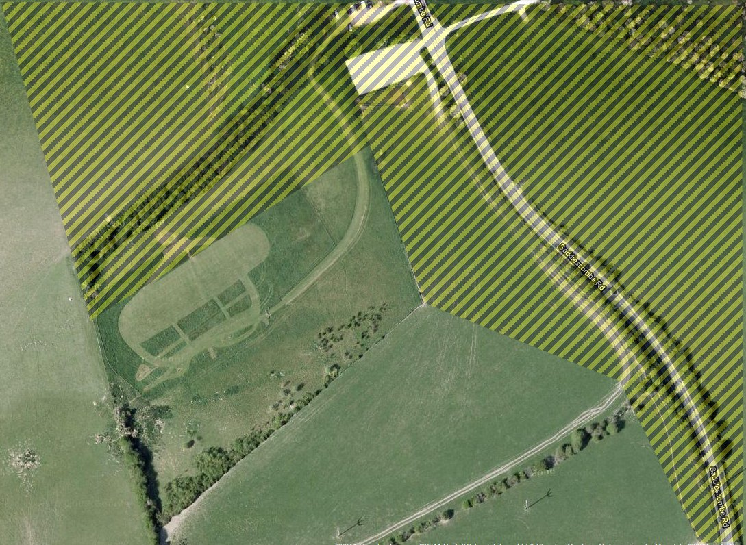
No Fly Zone North Side Evening Flying

15.6.2 No flying will be permitted 50 metres to the west of the second fence on the west side of the field, ie. heading towards Dyke Road and the Golf Club.

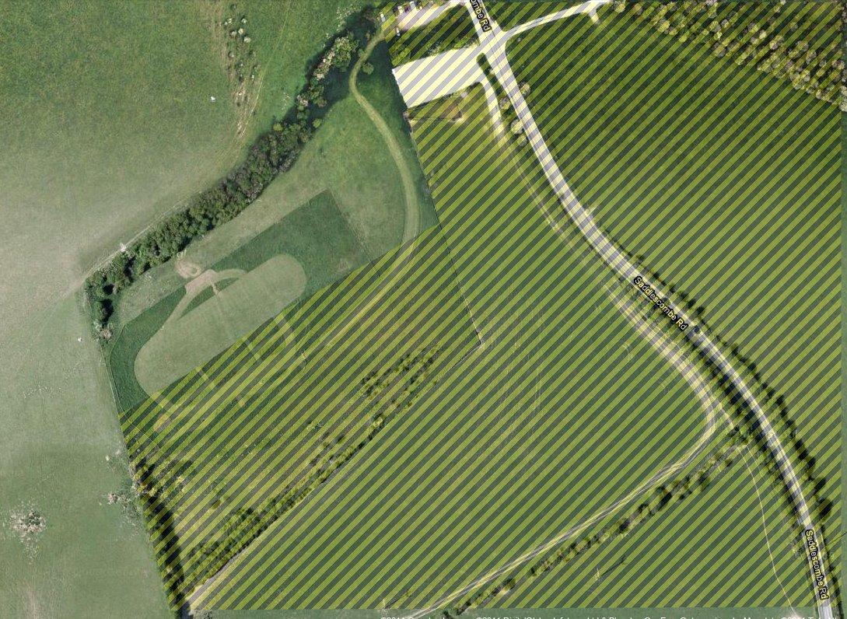
No Fly Zone South Side Normal Daytime Flying

15.7 STRIP

15.7.1 The purpose of the Safety lines will be adhered to at all times (i.e. Safety zone, Pilot area and pits as shown in the diagram)

    - Any spectators must remain in the spectators’ area whilst flying is in progress.

    - All running aircraft should be carried to the strip across the mown area in front of the pits and not through the rough ground, or behind the pits area.

    - Any person wishing to enter the runway area must call out their intentions and seek clearance from all pilots flying at the time, before doing so.

    - For safety reasons, all pilots (including handlaunch) should access the strip from the same end points and not from the centre of the strip. Pilots will stand in the designated pilot area. The central walkway must only be used to return to the pits after recovery of models. Pilots taking models to the strip via this route could be suspended from flying. (See diagram at 15.7.10.)

    - All take-offs must occur within the mown runway strip in the direction of the circuit of the day.

    - All fliers must observe the established flight line and stand in the designated Pilots area whilst flying.

    - No person shall attempt to retrieve a model from any land adjacent to the flying site without first assessing the situation and making sure minimal disruption is caused.

    - Members shall not climb over the barbed wire perimeter fences under any circumstances. To gain access to models landing outside the flying field, members must use the folding steps provided adjacent to the toilet area at the western edge of the flying field. If the model is beyond the next fence the steps can be unhooked from the fence post and carried across.

    - Field Layout & Walkways

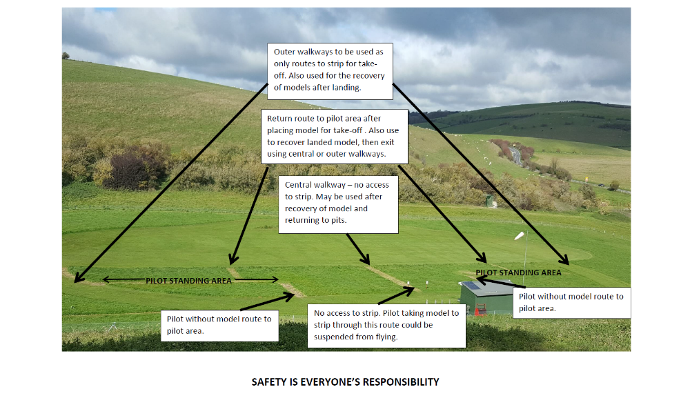
  - FREQUENCY CONTROL AND TRANSMITTERS

15.8.1 Recognisable frequency numbers or numbered coloured pennants must be displayed on FM transmitters at all times. Anyone without, will not be permitted to fly.

    - Each member will be provided with a blank orange frequency tag for 35MHZ (4”x 21/2” with ½” hole, top centre), which is to be marked with the member’s frequency number and name. Each tag must ONLY BE USED FOR ONE frequency number. If the member uses more than one frequency, then a separate tag for each frequency must be used.

    - A member’s current frequency tag must be placed on the frequency board before switching on their transmitter, and if sharing a frequency with others, the tag must be hung on their transmitter when not in use.

    - Members operating on 2.4 GHz will be provided with a white tag, on which they must display their name and attach it to the 2.4GHz board above the 35MHz frequency board.

    - All transmitters are to be checked on at least an annual basis in accordance with the guidelines in the BMFA handbook. Any transmitter found to be crossing over onto other channels is not to be used until the fault has been rectified.

    - All radio equipment will be type approved for use within the UK and will carry a CE mark.

    - Before switching on, the pilot must ensure that he is operating on the frequency he believes he is on and must display the appropriate frequency pennant on his transmitter.

    - All transmitter aerials must remain retracted unless the model is being flown. The flight is defined from the point of release to when the engine is stopped or the model is restrained.

    - Transmitters should not be taken away from the flight line when retrieving an aircraft, unless to do so would aid retrieval of the model. In this instance the matter should be brought to the attention of other pilots so that this may be carried out without the risk of over-flying the transmitter.

15.8.10 Should an aircraft go out of control, the first priority must be the safety of persons with the second being avoidance of damage to property. A warning “Heads up” is to be shouted by the pilot which is to be taken up by other members.

  - PIT AND ENGINE STARTING

    - Before starting an engine the model must be suitably restrained.

15.9.2 All I.C. engine powered and electric powered fixed wing aircraft must be safely restrained and facing the strip whilst being started. When started they must be physically restrained at all times until over the safety line, and upon returning to the pits must not be taxied over this line.

    - In the interest of safety, assistance should be sought when running up engines and taking models to the runway for take-off. All helpers must have BRFC membership.

    - The use of an assistant for pilots with IC Helicopters is mandatory for starting and carrying the model to the flight line.

    - Appropriate use should be made of all available pit area, and under no circumstances should engines be set up in the immediate vicinity of the pilots who are flying at that time. All models should face outward from the pit area.

    - Under no circumstances must an engine be run unless all persons are behind the line of the propeller with the exception of the person starting the engine. When carrying out power checks all persons including the pilot are to be behind the line of the propeller.

    - Models having their engines run in on the ground must not be left unattended whilst the engine is running.

    - All new or repaired models should be checked out by a club permit to fly holder, other than the owner, before being allowed to fly.

    - All models are subject to random safety spot checks which will be carried out by an instructor. If in his opinion a model is unsafe to fly or does not conform to Club rules, it will be grounded until rectified.

    - Members must ensure that powered models comply with the D of E Noise Code for the Minimisation of Noise from Model Aircraft and must pass sound testing before flying at the field. ‘Add on’ silencers and ‘quiet’ propellers should be fitted unless the model emits 82db or less without them. Notwithstanding if in the opinion of the Committee a model is excessively noisy in the air, then it is to be grounded until rectified.

    - Sound testing should be conducted in winds of no more than 3m/s (approx. 7mph) in line with DoE guidance. However, as a temporary measure, models may be tested in higher winds taking the arithmetic average of upwind and downwind readings +1db in order to comply with the 82db limit and allow flying for that session. The model will be retested at the next opportunity when the wind speed is 3m/s (approx. 7mph) or less.

    - All operational fail-safes in use on powered models operated from the Club site must set the throttle to tick-over, not hold, (stopped in the case of electric power), regardless of the other control operations governed by the failsafe. Particular care must be taken when operating on Pulse Code Modulation (PCM) or when swapping from normal modulation (PPM) to PCM to ensure that the failsafe is correctly programmed. Fail-safes are to be checked prior to flight by switching the transmitter off whilst the model is restrained. Correct failsafe operation of all models is part of the sound testing procedure and Permit to Fly test.

15.10 GAS TURBINES

15.10.1 Gas turbines are to be operated in accordance with BMFA Code of Practice for Safe Operation of Model Gas Turbines (a copy of which can be obtained from the BMFA or the Committee) together with the following rules, which are specific to the Saddlescombe flying site.

a. The operator must be the holder of a BMFA ‘B’ certificate.
b. Solo operation is not permitted i.e. At least two people must attend to operate, both of which must be competent flyers.
c. A Carbon Dioxide fire extinguisher must be on stand-by at all times.
d. Testing or starting up shall take place only in the designated area where models must be pointed into wind and mechanically restrained at all times.
e. Immediately prior to take off a range check should be made with the model being restrained by the helper.
f. All other aircraft present, whether I.C. or Gas Turbine will be grounded with radios off during any flight or flights.
g. UNDER NO CIRCUMSTANCES WILL A TAKE OFF BE PERMITTED IN AN EASTERLEY DIRECTION i.e. TOWARDS SADDLESCOMBE ROAD.

Rules a) to g) above will be subject to periodic reassessment.

15.11 FIELD SECURITY

15.11.1 Members can gain access to the flying field only by obtaining a set of keys requiring the payment of a non-returnable joining fee. The keys remain the property of the BRFC and should be returned on termination of membership. (Members who joined prior to 2006 remain entitled to the return of their £30 key deposit) The key is not transferable and is not to be copied.

    - When entering or leaving the car park, members MUST lock the gate behind them at all times. No parking is permitted outside the gate. Members are welcome to bring along their families and friends, but are requested to use one car to avoid congestion.

    - The last member to leave the flying site must raise and lock the post.

15.12 VEHICLES

    - All vehicles must be parked in the designated area only.

15.12.2 Vehicles are not permitted on the field at any time, unless carrying out club business, or with the permission of the Committee as a whole.

15.13 GENERAL

15.13.1 Mobile telephones should not be kept in close proximity to computerised transmitters and must not be taken onto the flight line.

15.13.2 Members are expected to observe the rules of the countryside and avoid any damage to adjoining farmland. No debris shall be left on the flying site, adjoining farmland or car park.

15.13.3 To minimise the risk of fire, smoking and the use of naked flames is not permitted within the pits or pilots area, or on the mown flying strip. (Smoking is permitted in the seating area behind the pits)

15.13.4 Children must be closely supervised at all times and must not be allowed to run around the pit area or runways.

15.13.5 No pets are permitted on the flying site.

Note: The above is not definitive and in the majority of Clubs, additional rules will be required to ensure that other requirements, hazards and risks are managed.

APPENDIX A

FIXED WING
PROFICIENCY TEST
PERMIT TO FLY

Affiliated to the British Model

Flying Association. Club Number 561

Name……………………………………….. Date………………………..
The following test to be carried out with a suitable aeroplane, without the aid of a gyro
PASS FAIL
1 | Take off & fly a figure of eight circuit over the field as directed
2 | Fly two left hand circuits.
3 | Fly two right hand circuits.
4 | Climb to a safe height and complete one loop.
5 | Complete a low level fly-by from each direction, then land.
6 | Take off, and when instructed, close the throttle to a tick-over and land to simulate a dead stick landing.
7 | Fail Safe
8 | To demonstrate knowledge of field safety procedures and no fly zones.

Three examiners/committee members are required to authorise the permit to fly.

Name: …………………………………………. Signature: …………………………………….

Name: …………………………………………. Signature: …………………………………….

Name: …………………………………………. Signature: …………………………………….

This is to confirm that ………………………….....
Has completed the permit to fly solo. Date: ………..
Examiner’s signature: …………..…………………

FIXED WING
TEMPORARY
PERMIT TO FLY

APPENDIX B

INCIDENT REPORT
FORM

Affiliated to the British Model

Flying Association. Club Number 561

This form should be used to report any accident or incident involving Club members, the general public, property or animals. All completed forms should be submitted to a Committee Member at the earliest opportunity.

Name of Person  Reporting Incident: | Membership Number:
Date of Incident: | Time of Incident:
Weather conditions:

Witness(es):

Who was involved:

Describe what happened (include as much detail as possible):

(Use reverse of sheet if necessary)
Were the emergency services involved? (please tick) YES NO

Signed: ………………………………………… | Date: …………………………………………….

Incident Reference No:
APPENDIX C

Affiliated to the British Model Flying Association  Club No. 561  DATA PROTECTION (GDPR) | BRFC CLUB  PRIVACY NOTICE
At the Brighton Radio Flying Club, hereafter referred to as “the club”, we’re committed to protecting and respecting your privacy.
We have not appointed a Data Protection Officer to oversee our compliance with data protection laws as we are not required to do so, but our Data Protection Compliance Manager has overall responsibility for data protection compliance in our club. Contact details are set out in the "Contacting us" section at the end of this privacy notice.
This notice explains when and why we collect personal information about people who join the club by whatever means, how we use it, the conditions under which we may disclose it to others and your rights in relation to your personal data.
We may change this notice from time to time so please check the website at brfc.bmfa.org or request a copy occasionally to ensure that you’re happy with any changes. By becoming a member of the club, you’re agreeing to be bound by this notice.
In future, when renewing your membership, your signature will be your consent to us keeping and using your data as described in this Privacy Notice.
Any questions regarding this notice and our privacy practices should be sent to the club Secretary via the ‘Contact us’ page on the Website: brfc.bmfa.org

How do we collect information about you?
We obtain information about you when you apply to become a member of the club either online via the club Website, in person or via the club application form.
What type of information is collected about you?
The personal information we collect might include your name, address, email address, telephone number, age and IP address.
The legal bases for the processing of your personal data is to enable the club to fulfil our contractual obligations and provide membership services.

How is your information used?
We may use your information to:
- process your membership;
- to carry out our obligations arising from your membership;
- seek your views or comments on matters relating to the club and model aircraft flying
- send you communications which you have requested and that may be of interest to you. These may include information about club events and contests and other club related matters, also information from the BMFA that may be of interest.
- Members’ and guest flyers’ names will be on display at the flying field, when appropriate for safe operation of the club. This will include, but not be limited to: recording models that have passed sound tests, frequency tags, guest flyer signing-in book and other related safety information.

How long do we retain your information?
We will hold your personal information on our systems for as long as is necessary to carry out our obligations in relation to your membership, or as long as is set out in any relevant agreement between us. Where an individual person’s club membership lapses your information will be securely kept for a period of up to one year, after which your information will be deleted. Guest flyers’ information will also be kept for up to one year.
Who has access to your information?
We will not sell or rent your information to third parties.
We will not share your information with third parties for marketing purposes.
All members of the club must also be members of the BMFA, by joining the club you give consent for your personal data to be shared with the BMFA to enable provision of BMFA membership services. Please see the BMFA privacy policy at https://www.bmfa.org/Privacy-Policy
Please be reassured that we will not release your information to third parties beyond the club unless we are required to do so by law, for example, by a court order or for the purposes of prevention of fraud or other crime.
How you can access and update your information?
The accuracy of your information is important to us. You can check the information we hold is correct and update if necessary by contacting the club secretary via the ‘Contact us’ page on the club Website.

What are your rights?
- the right to access;
You have the right to confirmation as to whether or not we process your personal data and, where we do, access to the personal data, together with certain additional information. That additional information includes details of the purposes of the processing, the categories of personal data concerned and the recipients of the personal data. Providing the rights and freedoms of others are not affected, we will supply to you a copy of your personal data. The first copy will be provided free of charge, but additional copies may be subject to a reasonable fee.
- the right to rectification;
You have the right to have any inaccurate personal data about you rectified and, taking into account the purposes of the processing, to have any incomplete personal data about you completed.
- the right to erasure;
In some circumstances you have the right to the erasure of your personal data without undue delay. Those circumstances include:
- the personal data being no longer necessary in relation to the purposes for which the data was collected or otherwise processed,
- you are no longer a club member and wish the data not to be held for our standard period of up to one year.
Please note a request for data erasure for a current member would require that member to forfeit membership. The data is required for the club to fulfill its obligations.
- the right to restrict processing;
In some circumstances you have the right to restrict the processing of your personal data. Those circumstances are:
- you contest the accuracy of the personal data;
- processing is unlawful but you oppose erasure;
- we no longer need the personal data for the purposes of our processing, but you require personal data for the establishment, exercise or defence of legal claims; and you have objected to processing, pending the verification of that objection. Where processing has been restricted on this basis, we may continue to store your personal data. However, we will only otherwise process it: with your consent; for the establishment, exercise or defence of legal claims; for the protection of the rights of another natural or legal person; or for reasons of important public interest.
- the right to object to processing;
You have the right to object to our processing of your personal data for direct electronic communications purposes. If you make such an objection, we will cease to process your personal data for this purpose and you would not be provided with club information.
- the right to data portability;
To the extent that the legal basis for our processing of your personal data is that the processing is necessary for the performance of a contract to which you are party and such processing is carried out by automated means, you have the right to receive your personal data from us in a structured, commonly used and machine-readable format. However, this right does not apply where it would adversely affect the rights and freedoms of others.
- the right to complain to a supervisory authority;
If you consider that our processing of your personal information infringes data protection laws, you have a legal right to lodge a complaint with the Information Commissioners Office. https://ico.org.uk
- the right to withdraw consent.
To the extent that the legal basis for our processing of your personal information is consent, you have the right to withdraw that consent at any time. Withdrawal will not affect the lawfulness of processing before the withdrawal. Please note that a request to withdraw consent for a current member would require that member to forfeit membership, as the data is required for the club to fulfil its obligations.

Contacting Us
If you have any questions or wish to exercise any of your rights in relation to your personal data, please contact the Club Secretary (Data Protection Compliance Manager) via the ‘Contact us’ page on the BRFC website.

